

 | User Guide |  |  | User Guide
 | Storage Billing System

Table of Contents
1 About this guide 3
1.1 Who Should Use It 3
2 Introduction 4
2.1 Purpose 4
2.2 Scope 4
3 Describing the System 5
3.1 Key Features 5
3.2 Environment 5
3.3 Screens – Intranet Home Page 6
3.4 Contract Table 7
3.5 Storage Rate Table 8
3.6 Delete Prebills 9
3.7 Tables 10
3.8 Programs 11
4 Appendix A – Reports/Emails 12
4.1 BNI Cargo awaiting storage email 12
4.2 BNI Vessels awaiting free time email 13
4.3 Prebills deleted email 14
4.4 BNI Autorun Storage Bill Results email 15

About this guide
This document has been prepared for the users of the Storage Billing System.

Who Should Use It
This guide is intended for users who have different degrees of knowledge and experience with the Storage Billing System:
- Port Finance Users can learn how to use the Storage Billing System to:
- Review daily emails to monitor status of free time and cargo awaiting storage billing
- Delete and undelete prebills
- Generate prebills
- Generate invoices
- Developers: The developers can learn how to Install and maintain the application

This guide assumes that you have some knowledge of the DSPC Intranet.

Introduction

Purpose
The purpose of the Storage Billing System is to give the DSPC Finance users the ability to have greater control over the billing process and reduce the manual intervention required by the prior system.
- The program will run nightly and automatically generate bills with a status of ‘on hold’ (aka prebills) to determine the records that are eligible for storage billing. Emails will be sent for the following:
  - List of vessels for which free time has not been set
  - List of cargo awaiting storage run
- The documents created for this application include this User Guide and the Requirements/Design Document.

Scope
The purpose of this guide is to help in the training of new users and to serve as a reference for all users. It documents the screens that are used in each process, the tables updated, and the reports available.

Describing the System

Key Features
The process begins when the free time for cargo expires and the storage billing period begins. Daily reports alert the users to any potential problems and expectations. Intranet screens allow the user to generate bills, delete and undelete prebills, and view reports.

Environment
- The online system runs in the Microsoft Internet Explorer environment and is made available through the Port of Wilmington’s Intranet site.
- Programs created for the new storage billing application include:
  - Storage_manualbills.php
  - Storage_autobills.php
  - Storage_no_freetimeset.php
  - Storage_bni_storage_prebills.php
  - storage_still_needed_bni.php
  - delete_bni_storage.php
  - set_free_time_for_autostorage.php

Screens – Intranet Home Page

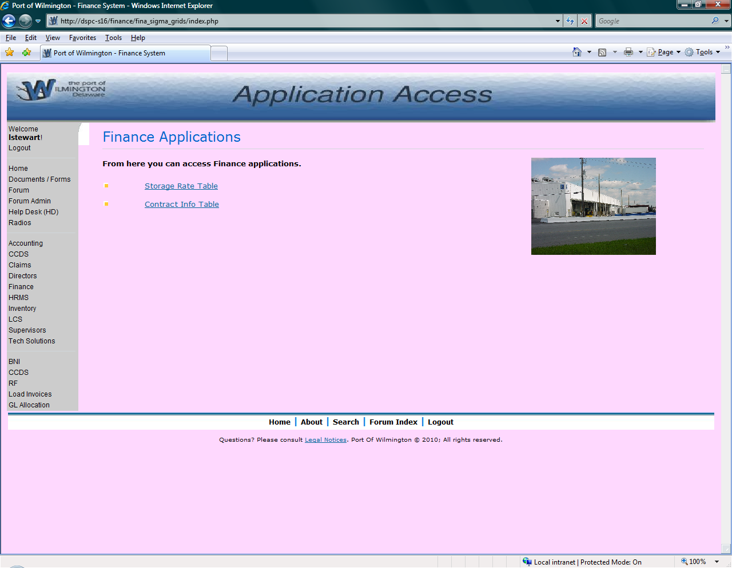

Log into the Intranet and go to Finance. Under Finance, select Tables at the bottom of the list. This will bring you to this screen where you can select either the Storage Rate or the Contract Rate Table.

Contract Table

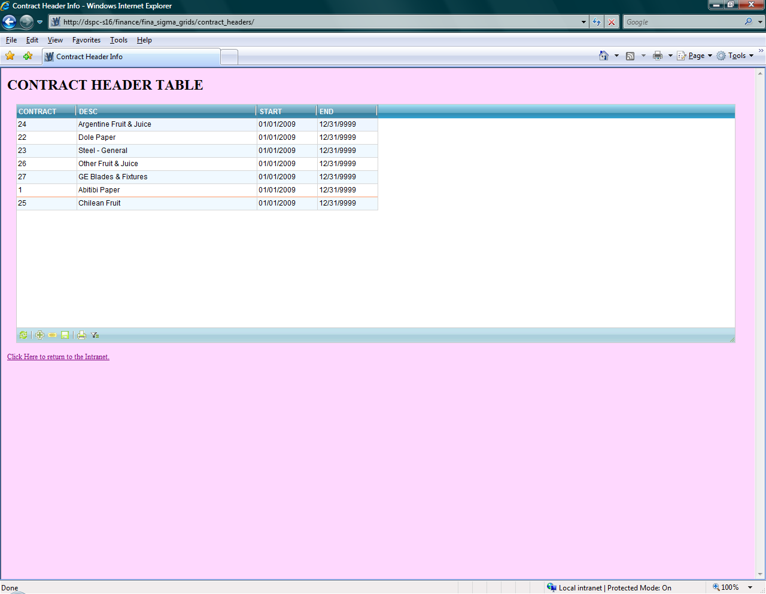

This table is used to enter a number, name, and start and end dates for a contract. This table must have an entry before rates can be input.

Storage Rate Table

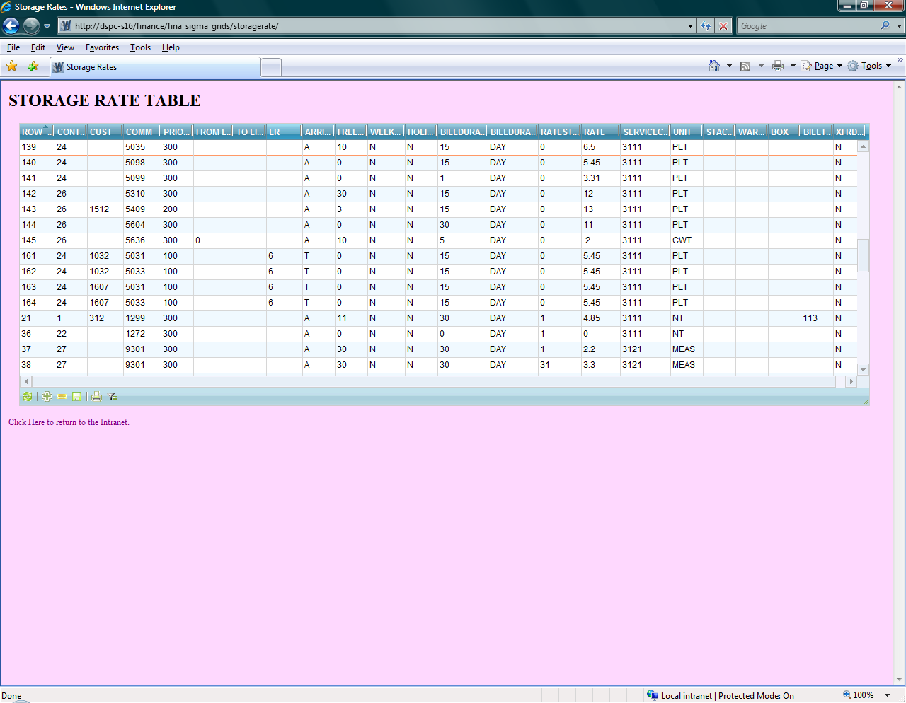

The rate table contains all rates for storage billing. The can be entered for a specific vessel, customer, contract, commodity, or combination of different fields. When more than one entry can apply, the priority in which the rate is determined must be entered.
If there is no rate, cargo cannot be entered.

Delete Prebills

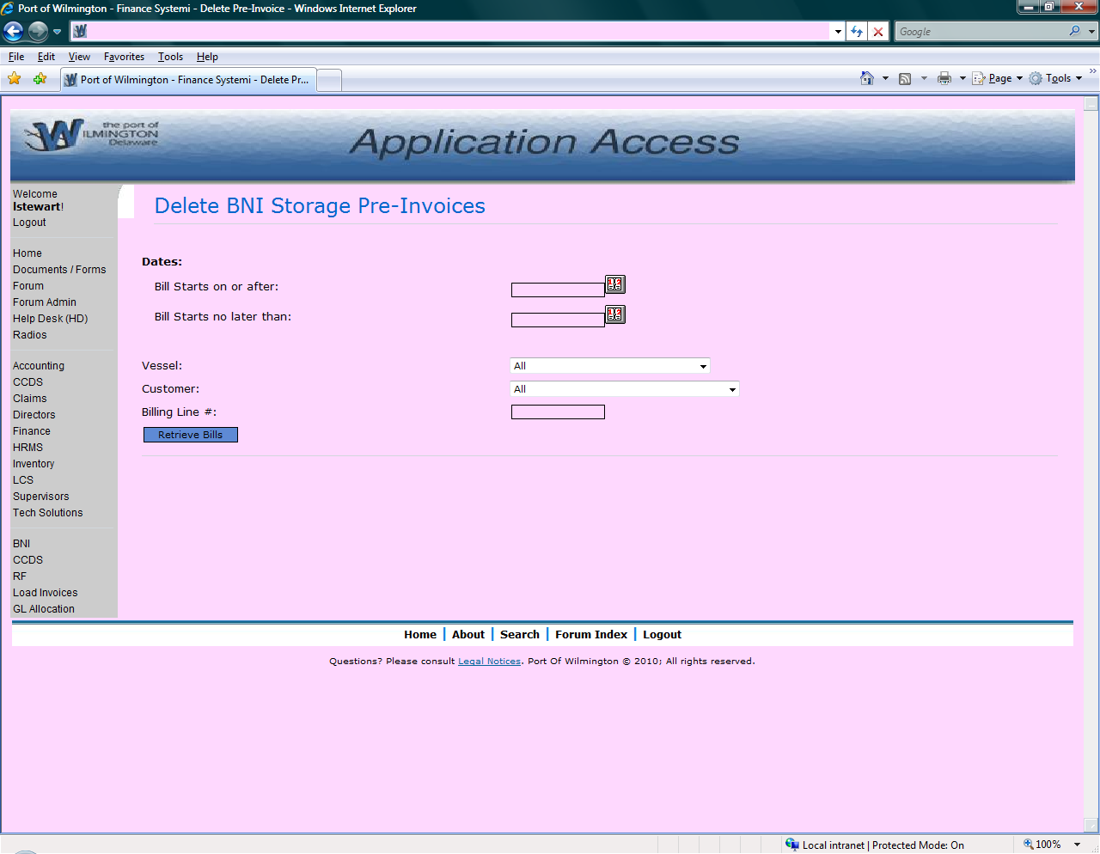

This application allows the user to delete an entire prebills, a date range of prebills, or those for a specific vessel, customer, or billing number. Entries can also be undeleted if necessary.

Database Tables & Programs

Tables
The following tables are available for Storage Billing processing and maintenance:
Table Name | Purpose
Rate | Stores rates for contracts
Contract | Stores contracts
Billing | Current table
Cargo_tracking | Current table

Programs
The following programs are used to display the screens and process the entered information
Program Name | Purpose
Storage_manualbills.php | Produce bills manually
Storage_autobills.php | Nightly automatic prebill generation
Storage_no_freetimeset.php | Nightly email of vessels that have not had free time set
Storage_still_needed_bni.php | Checks to see if storage will apply based on last billing date
Delete_bni_storage_prebills.php | Run if entry made on delete prebills screen
Set_free_time_for_autostorage.php | Takes free time value and applies to cargo on the vessel
Fina_sigma_grids/contract_headers | Runs when new/modified contract is saved
Fina_sigma_grids/storagerate | Runs when new/modified rate is saved
Select_bill.php | Modified to no longer handle storage prebills

3 programs can be eliminated once new system goes live:
- SetFreeTime.exe
- WhseRcpt.exe
- BNIStorage.exe

Appendix A – Reports/Emails

BNI Cargo awaiting storage email

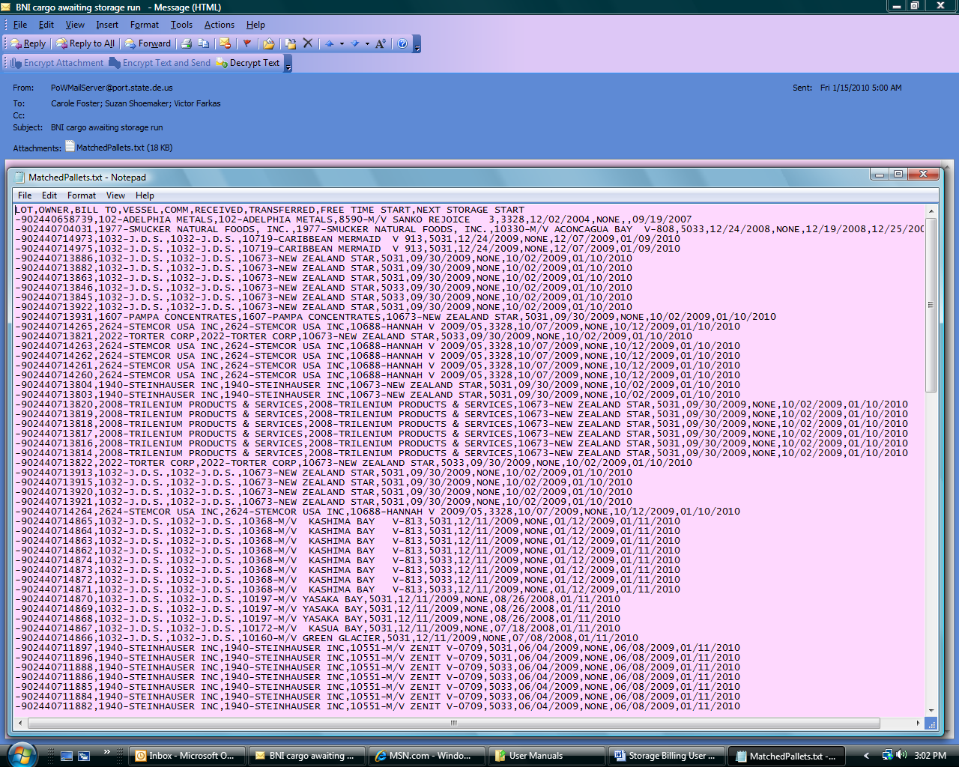

This email is sent daily at 5:00am. It lets the users know what cargo has not yet been billed for storage.

BNI Vessels awaiting free time email
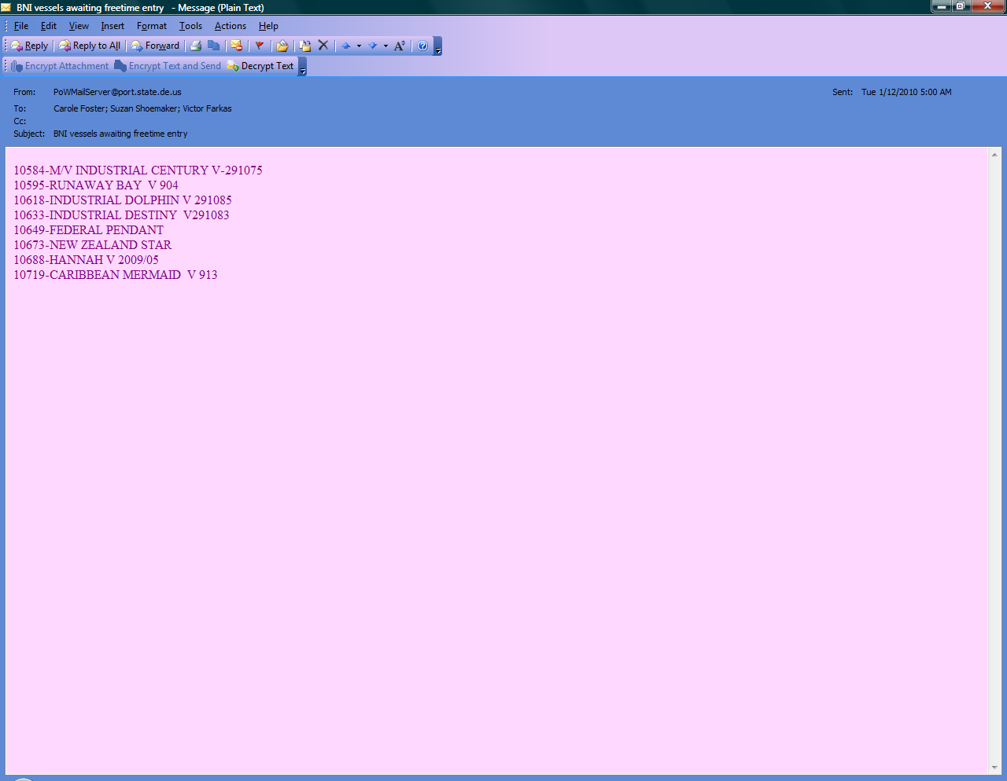

This email is generated daily at 5am and lists any vessels for which free time has not yet been set.

Prebills deleted email
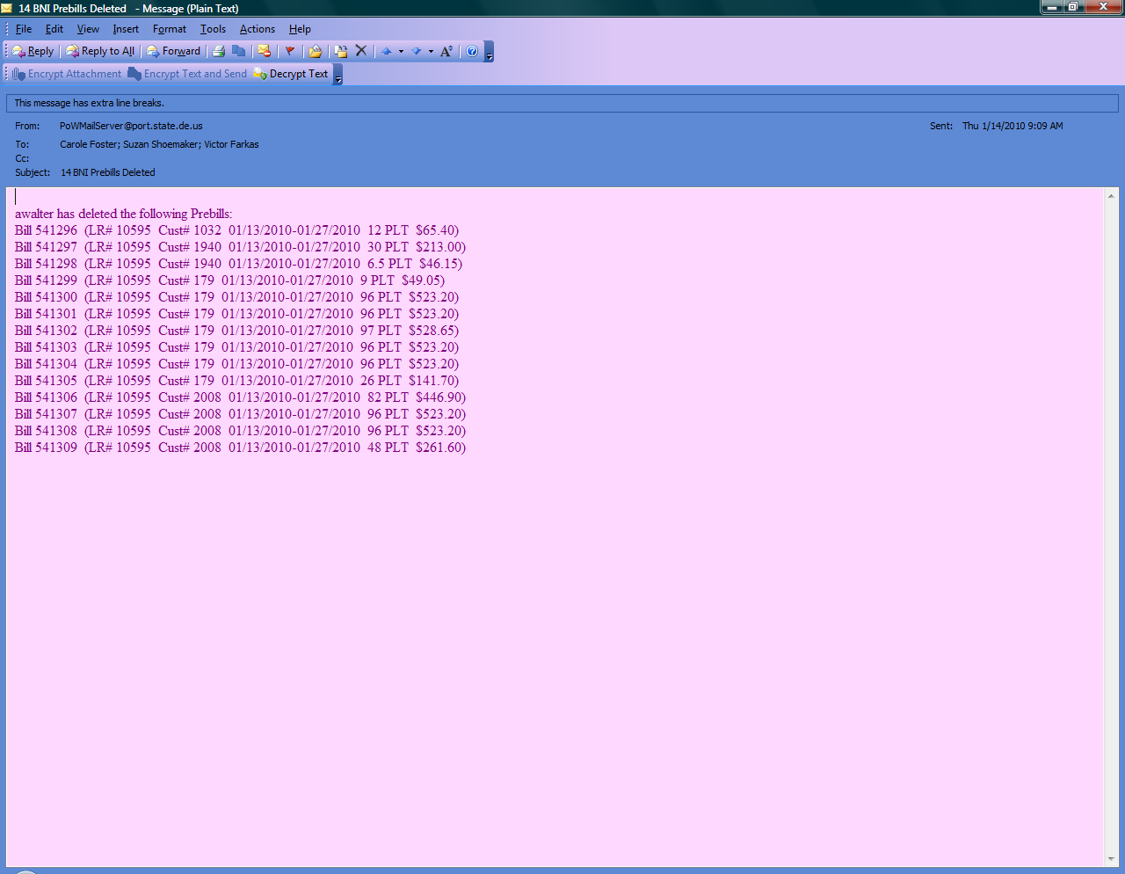

This email is generated immediately after an authorized user deletes a prebills entry.

BNI Autorun Storage Bill Results email

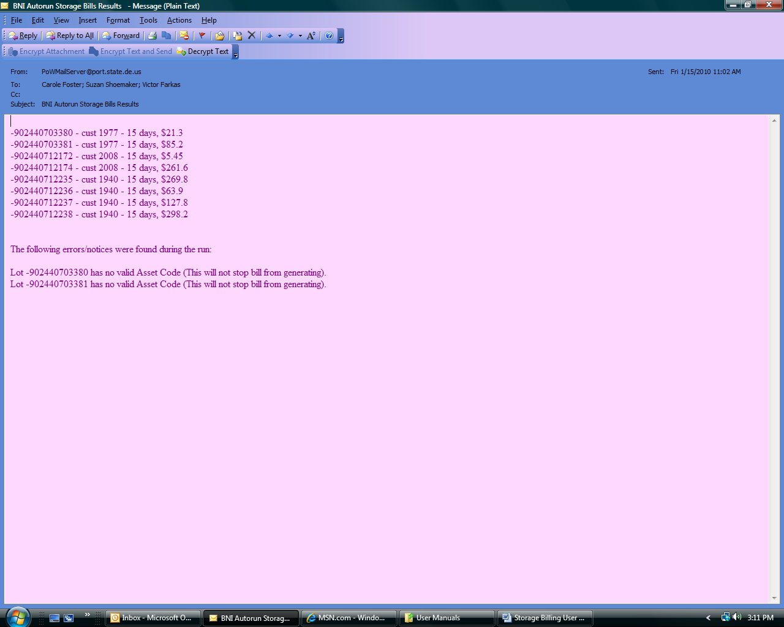

This email is sent after the Storage run is generated by Accounting. It lists the results of the prebills run.

